|  |  |
| --- | --- |
| **Purple diagram of mountains and sea  Logo text: University of the Highlands and Islands, Executive Office, Ness Walk, INVERNESS IV3 5SQ  Oilthigh na Gàidhealtachd agus nan Eilean, Slighe Nis, Inbhir Nis IV3 5SQ** |  |

**Please attach these pages to the front of your assessment.**

|  |  |  |  |
| --- | --- | --- | --- |
| **Student ID &**  **Student Name** | **21010093**  **Calum Lindsay** | **Date submitted** |  |
| Programme title | HNC Computing | | |
| Unit number | J0HK 34 | | |
| Unit title | Ethical Hacking | | |
| Learning outcome number | **Assessment 2** (covers Outcome 2,3 & 4) | | |
| Learning outcome title | Plan a penetration test.  Use current techniques to undertake a penetration test and exploit system vulnerability.  Implement appropriate countermeasures to mitigate a cyber-attack | | |
| Word count | N/A | | |

|  |  |
| --- | --- |
| **Checklist** | ✔ |
| Citations in the text use the UHI Harvard referencing system | N/A |
| All cited sources are listed alphabetically and in full in the bibliography | N/A |
| Word count is within 10% of the target length | N/A |
| File saved with the filename format ‘Student number_unit initials_LO number’ | N/A |

The University of the Highlands and Islands recognises that malpractice, where deliberately engaged in, is unacceptable and is considered a serious academic offence. A full copy of the university’s Malpractice Policy and Procedure can be found here: <https://myuhi.sharepoint.com/Policies/Forms/Public%20view.aspx>

Students are responsible for ensuring the work they submit is their own and complies with the ASQR and Malpractice Policy. If you have any queries you should contact your unit lecturer or Personal Academic Tutor (PAT) before submitting your assessment.

Please note that any case of suspected malpractice will be investigated according to current UHI Academic Standards and Quality Regulations (ASQR).

|  |  |
| --- | --- |
| In submitting this work, I confirm that I have read and understood UHI ASQR and malpractice policy and am aware of the possible penalties. | **🗸** |

|  |  |
| --- | --- |
| **Originality checker (to be completed if Turnitin is used)** | **🗸** |
| I confirm that I received information about the use of Turnitin and was directed to Turnitin training | **N/A** |
| I understand that this assignment will be submitted to Turnitin for originality checking | **N/A** |

|  |
| --- |
| **If you have received feedback/feedforward from coursework or an assignment for this unit/module/course, state the next steps**  You can either cut and paste these from previous assignment / coursework feedback, or pick some elements that you have decided you would like to work on |
|  |
| **If you have received feedback/feedforward from coursework or an assignment for this unit/module/course, state what you have done to address the next steps** |
|  |

**For staff use only**

|  |  |  |  |
| --- | --- | --- | --- |
| Lecturer contact number: [1] | | | |
| Lecturer email: euan.robertson@uhi.ac.uk | | | |
| Feedback/feedforward return date | |  | |
| Feedback |  | | |
| Feedforward |  | | |
| Pass / Fail - to be ratified at Progression Board  (or Grade for HN Graded Units only) | | |  |
| Sampled for Internal Verification | | | Yes / No |
| **Assessment attempt:** 1 or 2 | | |  |
| **Is an application for an additional attempt in exceptional circumstances required? Yes / No** | | | |

Scope Report of Trilogy Europe

Investigation overview:

Trilogy Europe are a multi-national manufacturing company. They wish to tender for military contracts and therefore, wish to ensure their systems are resilient to cyber-attacks. They wish to keep this investigation internal to the company and don’t want anything related to it to leak to the news or general public. They want me to perform an internal penetration test on a portion of their network which is only used by the research and development section of the company as this is where the military work will be carried out. I will collate the results of this testing and produce a report detailing any threats and vulnerabilities found and any countermeasures I would recommend putting in place.

## Scope Report

*In the stages below discuss the procedure, tools used, commands run, findings – include screen shots as evidence.*

### Planning Stage:

*Pen-test completed and submission date: 26/04/2022*

* An internal investigation of the 192.168.10.16/28 Network is to be performed.
* Full access is allowed to all data within the network which includes creation, viewing or deletion of all files and other data stored on devices within the network.
* Everything within the network can be tested in any way.
* No social engineering will be performed.
* No external testing will be performed.

### Reconnaissance Stage:

First Zenmap was used to detect what devices were connected to the network and retrieve information about them. Zenmap discovered 3 devices one of which is the Kali-Linux computer that we are using to perform the penetration testing.

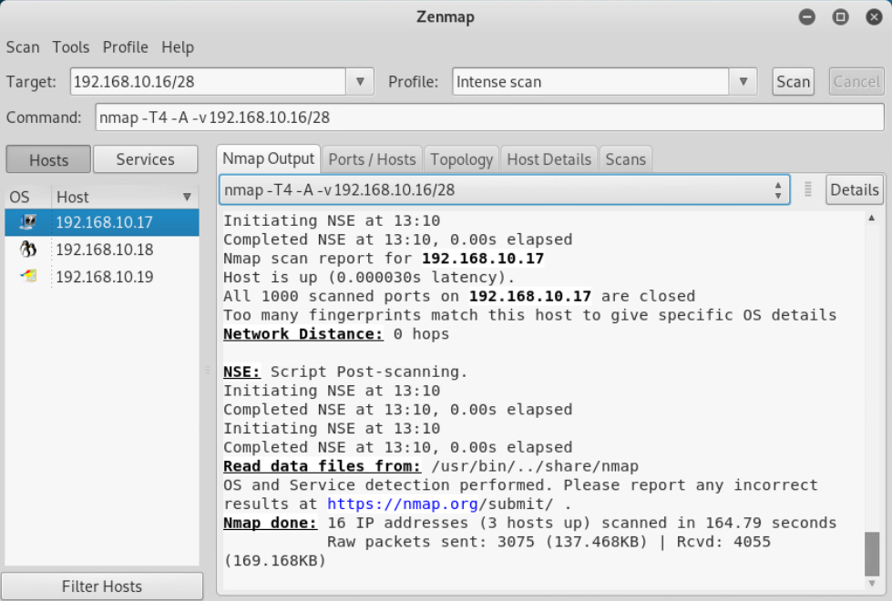

Details discovered about the other 2 devices to be tested are shown below in the following tables:

|  |  |  |
| --- | --- | --- |
| Ip Address | Open Ports / Scanned Ports | Operating System |
| 192.168.10.18 | 23/1000 | Linux 2.6.9 – 2.6.33 |
| 192.168.10.19 | 5/1000 | Microsoft Windows XP SP0 - SP1 |

|  |  |  |  |
| --- | --- | --- | --- |
| **192.168.10.18 – Open Ports And Services** | | | |
| Port | Protocol | Service | Version |
| 21 | tcp | ftp | vsftpd 2.3.4 |
| 22 | tcp | ssh | OpenSSH 4.7 |
| 23 | tcp | telnet | Linux telnetd |
| 25 | tcp | smtp | Postfix smtpd |
| 53 | tcp | domain | ISC BIND 9.4.2 |
| 80 | tcp | http | Apache httpd 2.2.8 |
| 111 | tcp | rpcbind | 2 (RPC #100000) |
| 139 | tcp | netbios-ssn | Samba smbd 3.X – 4.X |
| 445 | tcp | netbios-ssn | Samba smbd 3.0.20 – Debian |
| 512 | tcp | exec | netkit-rsh rexecd |
| 513 | tcp | login | openBSD or Solaris rlogind |
| 514 | tcp | shell | Netkit rshd |
| 1099 | tcp | java-rmi | Java RMI Registry |
| 1524 | tcp | bindshell | Metasploitable root shell |
| 2049 | tcp | nfs | 2-4(RPC #100003) |
| 2121 | tcp | ftp | ProFTPD 1.3.1 |
| 3306 | tcp | mysql | MySQL 5.0.51a – 3ubuntu5 |
| 5432 | tcp | postgresql | PostgreSQL DB 8.3.0 – 8.3.7 |
| 5900 | tcp | vnc | VNC (protocol 3.3) |
| 6000 | tcp | X11 | Unknown |
| 6667 | tcp | irc | UnreallRCd |
| 8009 | tcp | ajp13 | Apache Jserv (Protocol v1.3) |
| 8180 | tcp | http | Apache Tomcat/Coyote JSP engine 1.1 |

|  |  |  |  |
| --- | --- | --- | --- |
| **192.168.10.19 – Open Ports And Services** | | | |
| Port | Protocol | Service | Version |
| 135 | tcp | msrpc | vsftpd 2.3.4 |
| 139 | tcp | netbios-ssn | Microsoft Windows netbios-ssn (Unknown) |
| 445 | tcp | microsoft-ds | Windows XP microsoft-ds (Unknown) |
| 1025 | tcp | msrpc | Microsoft Windows RPC (Unknown) |
| 5000 | tcp | upnp | Unknown |

Another penetration testing tool was used by the name of Armitage to gather information on the 2 computers. Armitage will scan the network similarly to how Zenmap did and then we can make it “Find attacks” which will give us a list of potential attacks that we can use on the systems to attempt to gain access based on the services running on the systems, the operating systems they are using and the versions of these software packages.

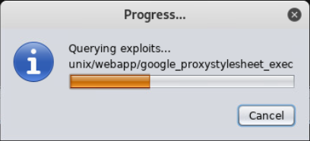

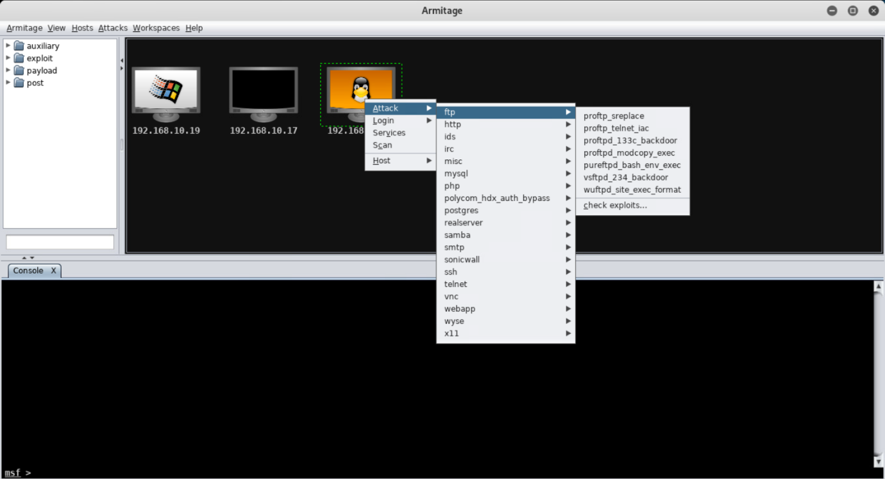

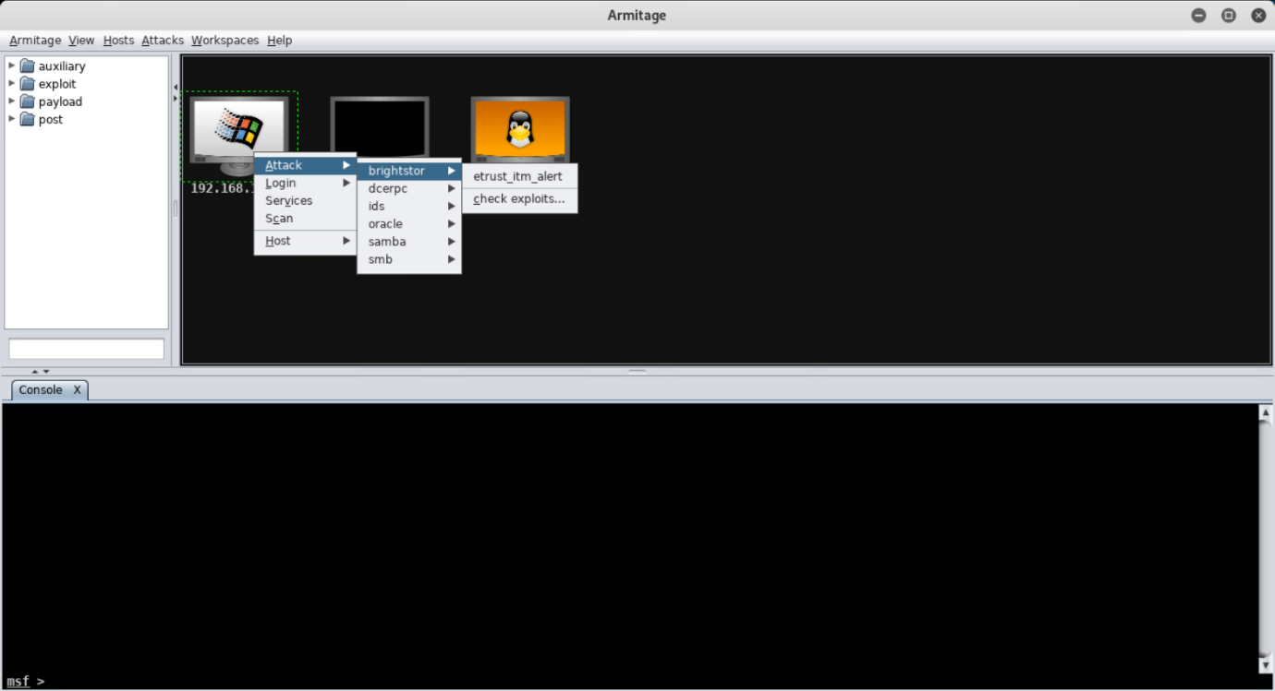

As you can see Armitage has found a number of attacks worth attempting on the Linux machine and much fewer on the Windows machine. When we attempt to gain access later we will produce a table detailing which attacks were attempted and which failed or succeeded.

***Evidence use of both command tools and graphical tools on at least 2 end systems to demonstrate system or web-based security vulnerability testing?***

### Gaining access Stage:

*Explain how you gained access.*

*Found exploits and executed them*

*Password Cracking*

*Telnet – command prompt*

*Mysql - command prompt*

### Maintaining Access Stage:

*Explain how a system admin account was created on the end system.*

### Covering Tracks Stage:

*Explain how you removed evidence of your intrusion on any system – files, users, logs etc*

### Implement Countermeasures Stage:

***How*** *could the systems investigated by made more secure?   
If you can perform these system improvements then do so. On the Metasploitable system this isn't possible so just* ***explain*** *how they could be implemented.*

### Report conclusions and recommendations:

*Summarise your finding and state recommendations for Trilogy Europe.*

# APPENDIX 1:

# Penetration Test Agreement

This agreement is made as of 26/04/2022 By and between: Calum Lindsay, located in 5 Brough View, Cullivoe, Yell, Shetland; hereafter referred to as ‘Calum Lindsay’ and Trilogy Europe, located in London; represented by James Amstel, hereafter referred to as the ‘customer’.

With regard to the Penetration Test, the customer hereby acknowledges and agrees:

1. That Calum Lindsay will perform a Penetration Test — which will consist of a partially automated test that will attempt to remotely identify security vulnerabilities and/or any software misconfiguration — on one or more computer systems owned and/or operated by the customer.
2. That the customer has the legal right to subject the designated computer system to the aforementioned Penetration Test and that if it is not the owner of the computer system it has obtained such right from the legal owner of the system.
3. Not to hold Calum Lindsay liable for any indirect, special, incidental, or consequential damage, which will include but not be limited to loss of business, revenue, profits, use, or data, however it may arise.
4. That it has the sole responsibility for adequate protection and backup of data and/or equipment used in connection with this Penetration Test and will not make a claim against Calum Lindsay for lost data, backup restoration time, inaccurate output, work delays or lost profits resulting from the Penetration Test.
5. That Calum Lindsay will not divulge any information about the customer's network it received as a result of this Penetration Test. All results are confidential and belong to the customer.
6. That it should recognise that the results of this test will provide a reasonably accurate view of the current security level of the tested computer system(s), Calum Lindsay can not be held responsible if the Penetration Test fails to discover certain security or configuration issues on the target computer system(s).
7. The customer’s systems will respond in a normal fashion when they detect the Penetration Test in its firewall logs, alert systems, etc as it would do in the case of a real security penetration; this is so that it will not distort the results of the test. However, the customer agrees not to notify legal or public authorities of this penetration.

The customer requests Calum Lindsay to perform the Penetration Test on the following IP address(es) under the aforementioned conditions:

* 192.168.10.17
* 192.168.10.18
* 192.168.10.19
* 192.168.10.20
* 192.168.10.21
* 192.168.10.22
* 192.168.10.23
* 192.168.10.24
* 192.168.10.25
* 192.168.10.26
* 192.168.10.27
* 192.168.10.28
* 192.168.10.29
* 192.168.10.30

Calum Lindsay will inform the customer of the Penetration Test originating IP address.

Calum Lindsay________________________________________

Signed for and on behalf of Calum Lindsay

J Amstel________________________________________

Signed for and on behalf of the customer. Company legally binding signature required.

1. Note: the lecturer contact number and email may not be used to contest a mark. Please see the latest version of the UHI academic regulations <https://www.uhi.ac.uk/en/about-uhi/governance/policies-and-regulations/regulations> for more information.